The Amityville Horror:
The House That Turned a Crime Into a Global Legend.
By Swetha on July 9 at 11:00 am IST
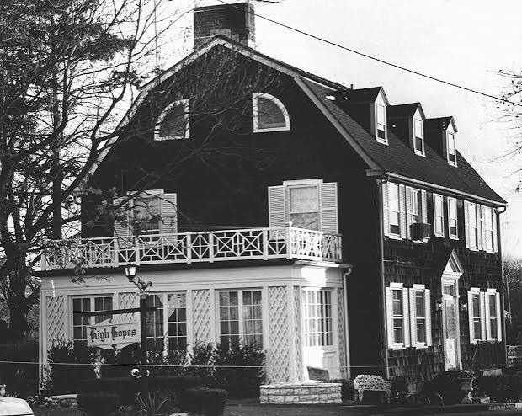

Some houses become homes.

Others become warnings.

Few horror stories have blurred the line between fact and legend like the Amityville Horror. Behind the walls of 112 Ocean Avenue in Amityville, New York, a brutal family massacre in 1974 was followed by shocking claims of demonic activity, paranormal investigations, and decades of controversy. Even today, the question remains:

Was the house truly possessed by evil, or was the horror created by fear and imagination?

This is the story behind the Amityville Horror.

The Night of the Murders
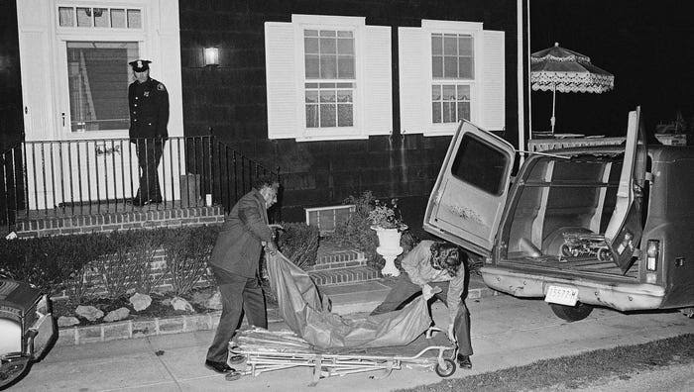

On November 13, 1974, Ronald "Butch" DeFeo Jr. murdered his parents and four younger siblings inside their home at 112 Ocean Avenue.
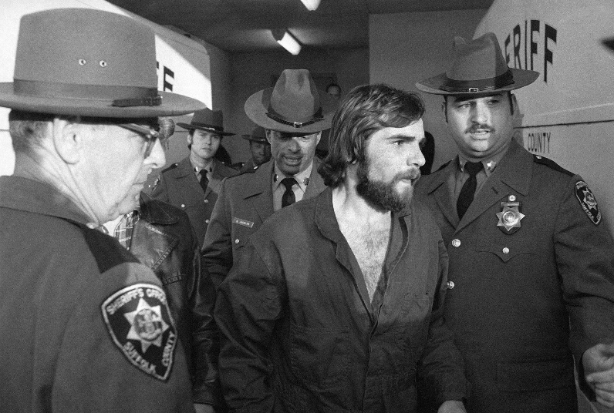
After his arrest, Ronald confessed to the killings but later claimed he had been driven by mysterious voices. According to him, these voices belonged to a demonic force that ordered him to kill his family. He described feeling controlled by an unseen evil presence and insisted he had not acted alone. However, his story changed several times over the years, leaving investigators uncertain whether he truly believed he was possessed or was simply trying to escape responsibility.
Despite his claims, Ronald was convicted of six counts of second-degree murder.

The Lutz Family's Paranormal Claims

Just over a year later, George and Kathy Lutz bought the house. Only 28 days after moving in, they fled, claiming the property was under the influence of a malevolent demonic presence.
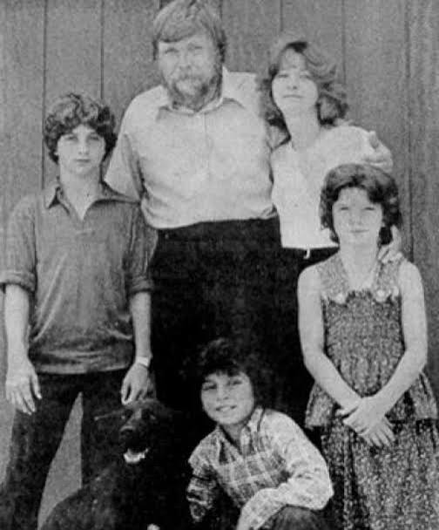
The family reported waking every night at 3:15 a.m., hearing unexplained footsteps and growls, doors and windows opening by themselves, freezing cold spots, foul sulfur-like odors, green slime oozing from walls, swarms of flies during winter, shadow figures, and an unseen force that seemed to affect George's personality, making him increasingly angry and withdrawn.
A Catholic priest who reportedly visited the house claimed he heard an unseen voice shout, "Get out!", and later suffered unexplained health problems after attempting to bless the home. These accounts strengthened the belief that the house was not simply haunted but influenced by a demonic entity. One of the most disturbing discoveries was a small hidden basement chamber the family called the "Red Room". Although it appeared to be an ordinary storage space, they believed it radiated an overwhelming sense of evil and served as the center of the alleged demonic activity.

Paranormal Investigation
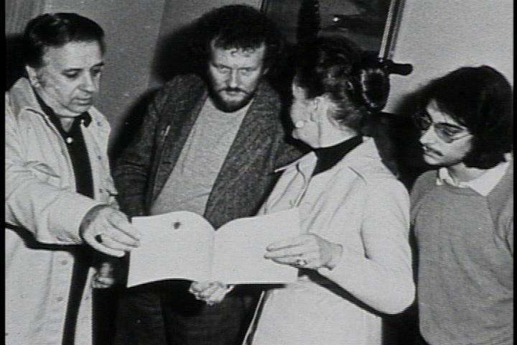
After the Lutz family left, paranormal investigators Ed and Lorraine Warren visited the property in 1976 with a team of photographers, psychics, and television reporters.

The Warrens claimed they sensed an intense demonic presence unlike anything they had previously encountered. Lorraine Warren later stated that she experienced terrifying visions connected to the murders, while Ed believed the house had been influenced by an inhuman entity rather than ordinary ghosts.
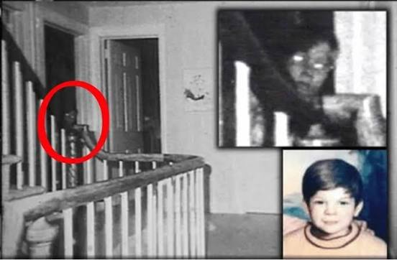
During the investigation, photographer Gene Campbell captured the now-famous image of what appeared to be a young boy with glowing eyes peering from a hallway. Supporters consider it one of the most convincing paranormal photographs ever taken, while skeptics argue it simply showed another investigator standing in the hallway.
Some paranormal researchers also suggested the house had been built near land once used by Indigenous communities or a site connected to dark spiritual practices. However, historians have found little evidence supporting these claims, and they remain part of the legend rather than established fact.

Fact or Fiction?
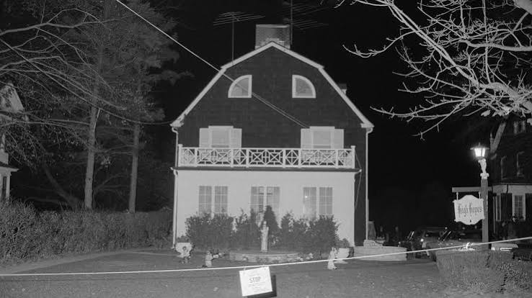

The Lutz family's experiences became the basis for The Amityville Horror, published in 1977. The bestselling book inspired numerous films, documentaries, and television programs, making the house one of the most recognizable haunted locations in popular culture.
Despite its fame, the case remains highly controversial. Many journalists, investigators, and later homeowners disputed the paranormal claims, pointing out inconsistencies in witness accounts and the lack of scientific evidence. Others argue that the emotional trauma surrounding the murders may have contributed to the family's experiences.
Even today, believers maintain that the house was affected by a demonic presence, while skeptics consider it one of history's most successful paranormal hoaxes.

Conclusion

More than five decades later, the Amityville Horror remains a mystery that refuses to die.
Whether the house was truly cursed by a demonic presence or the legend was born from fear and tragedy, no one can say for certain.

Long after the lights went out inside 112 Ocean Avenue,
the darkness it left behind continues to linger waiting for the next believer to wonder what really happened within those walls.

